**User Interface Design - Assignment**

**AUMS Interface Evaluation**

*CB.EN.U4CYS21089*

*G.Yaswanth*

AUMS (Amrita University Management System ) is a website that comes under amrita.edu which lets Students, Faculty, and management staff access and view information about exams, academic scores, attendance, and grade.

Students can write exams and view scores

Under **REGISTRATION** => The users can also register for new courses and check the already registered courses.

Under **VIEW** **DUES** => The users can also see the records of payments and dues at their particular department.

Under **PERSONAL** => The user can access the updated profile and view the profile. The user can view [  Student, Qualifying Exam, Personal, Address, Contact, Health, Photo ].

Under **OPAC** => The user can look up all the digitally available books and reserve a book if he/she has a library membership.

Every registered course will have a lot of options => 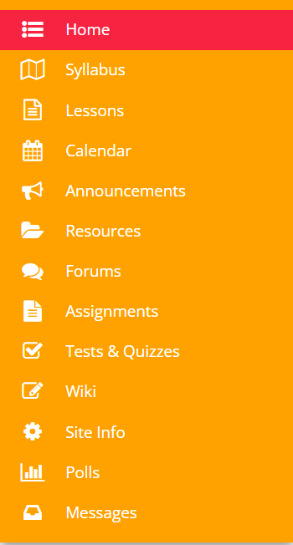

These options can be utilized by the user for the appropriate work.

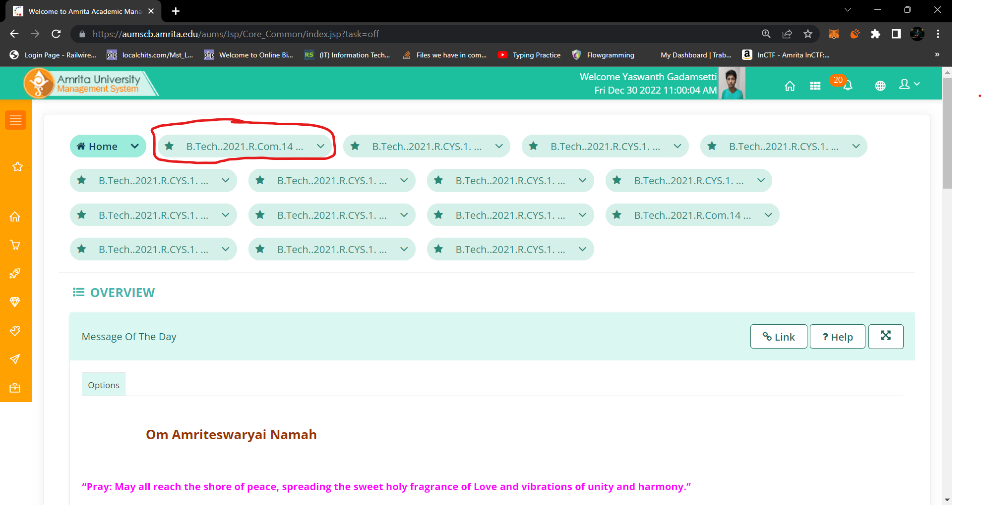

The field that was highlighted in red is a “B.Tech..2021.R.Com.14 ...” but the actual course name is “B.Tech..2021R.R.Com.14.19AVP2021” The filed size should be increased so the users can see the course names more clearly.

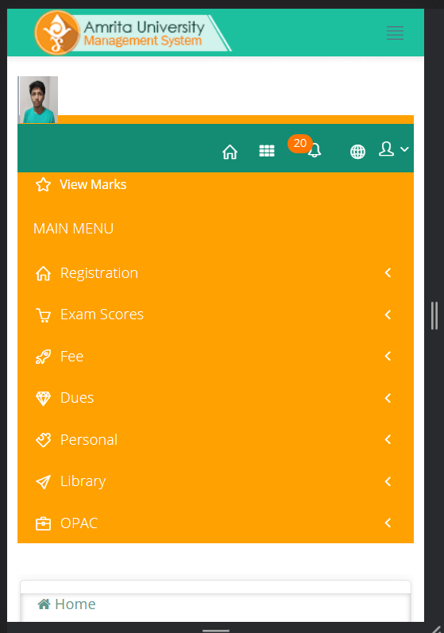 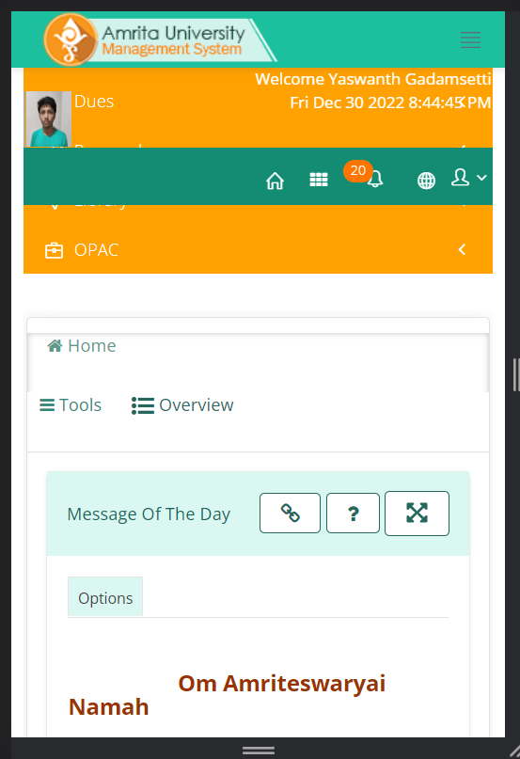

In the mobile frame the name, dd-mm-year, time is only visible under a few conditions. The color of the text should be changed.

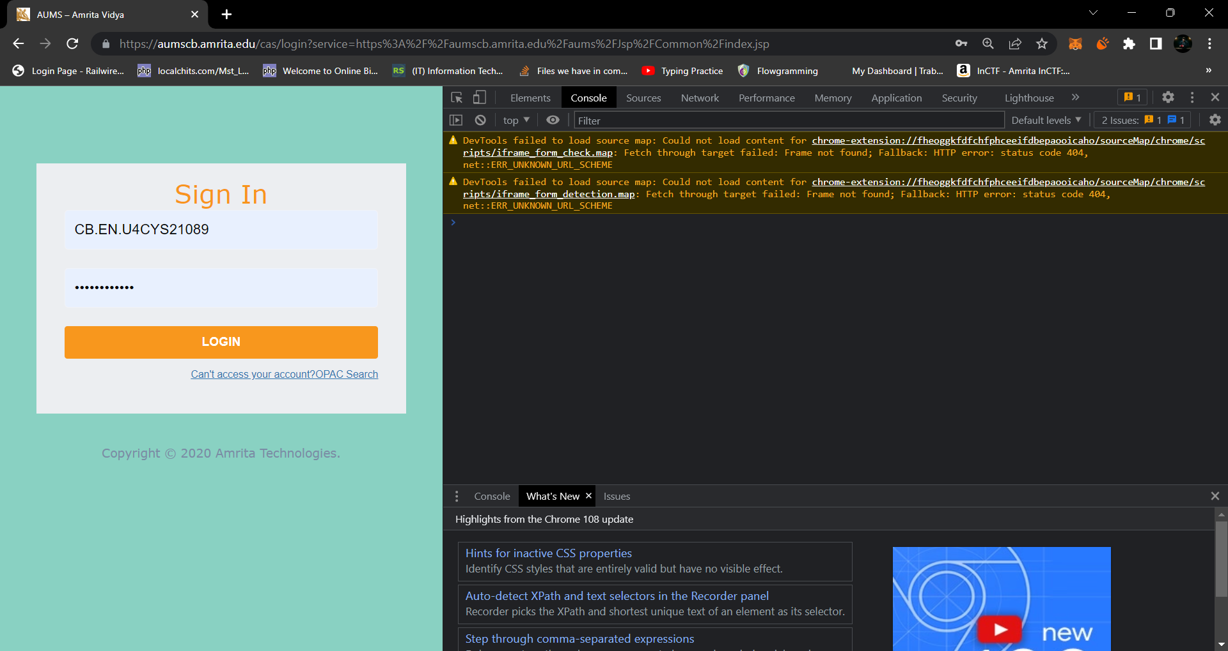

There are a few errors with the JavaScript of the AUMS website.

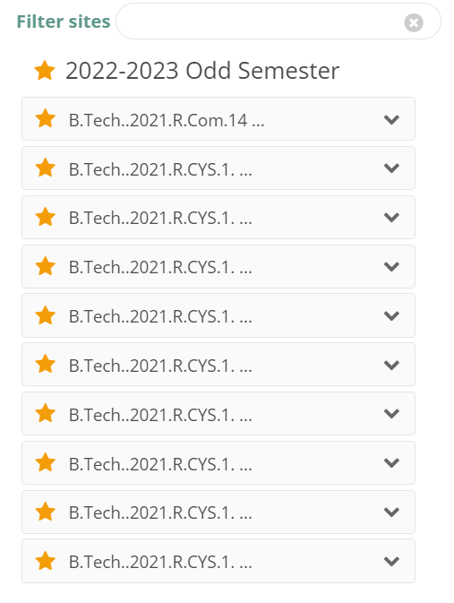

The course names are not clearly displayed, making it difficult for the user to find a specific course.

The fields are not properly aligned and are crowded for the tabs below:

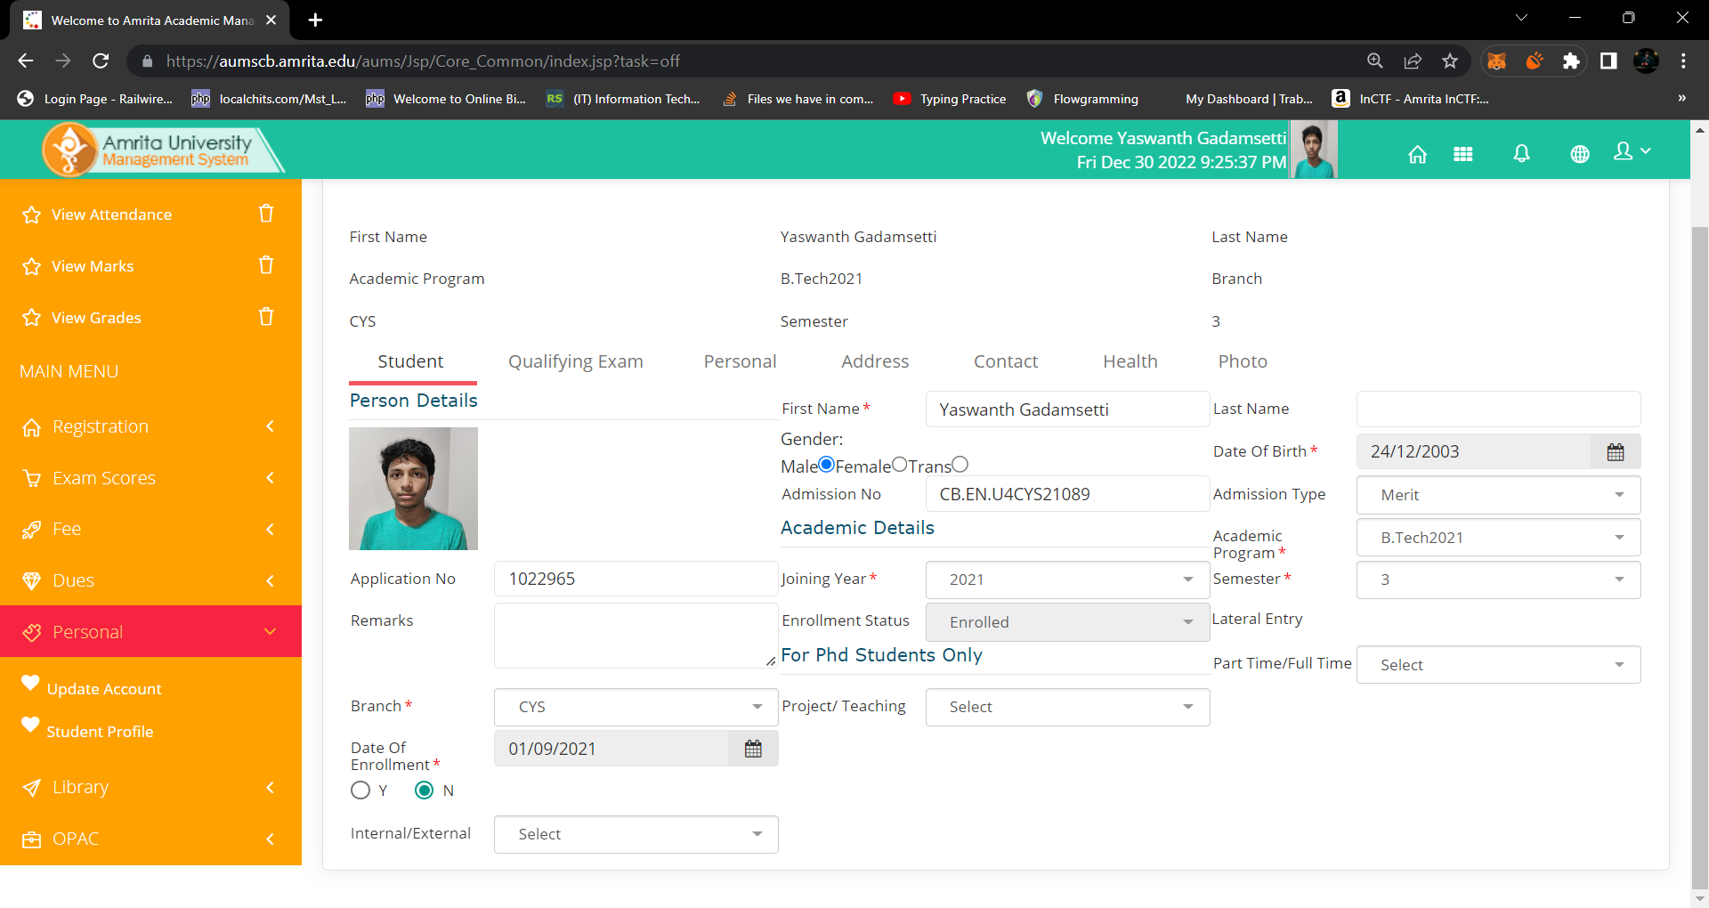

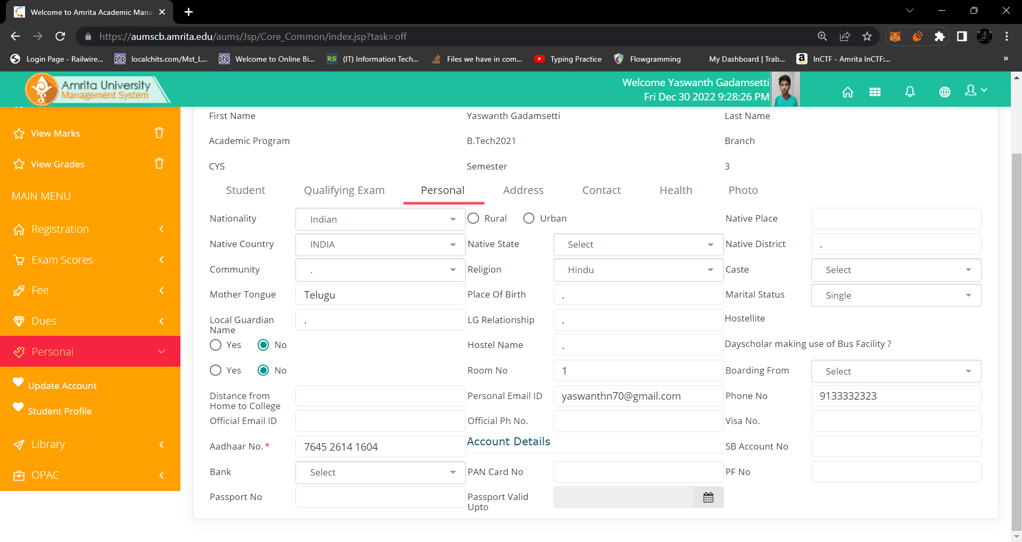

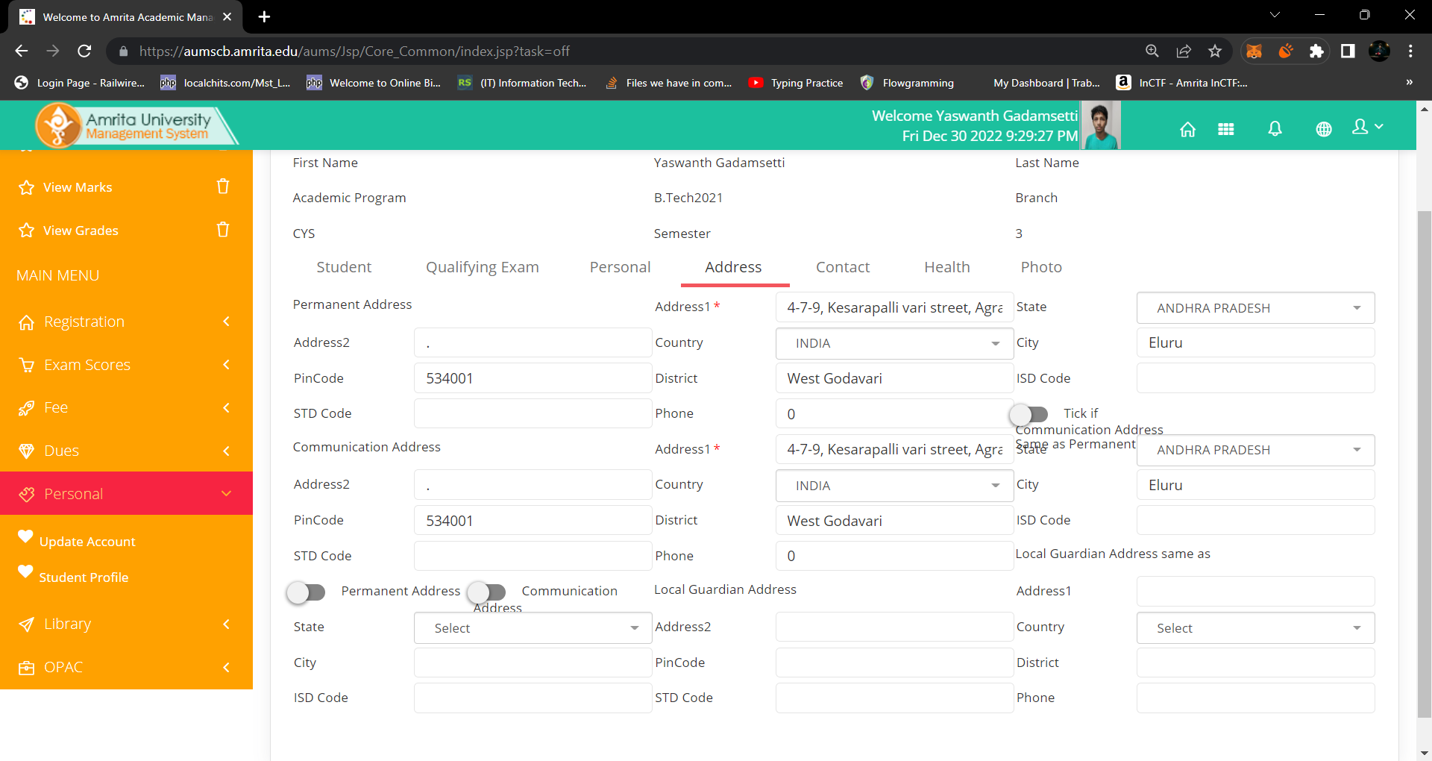

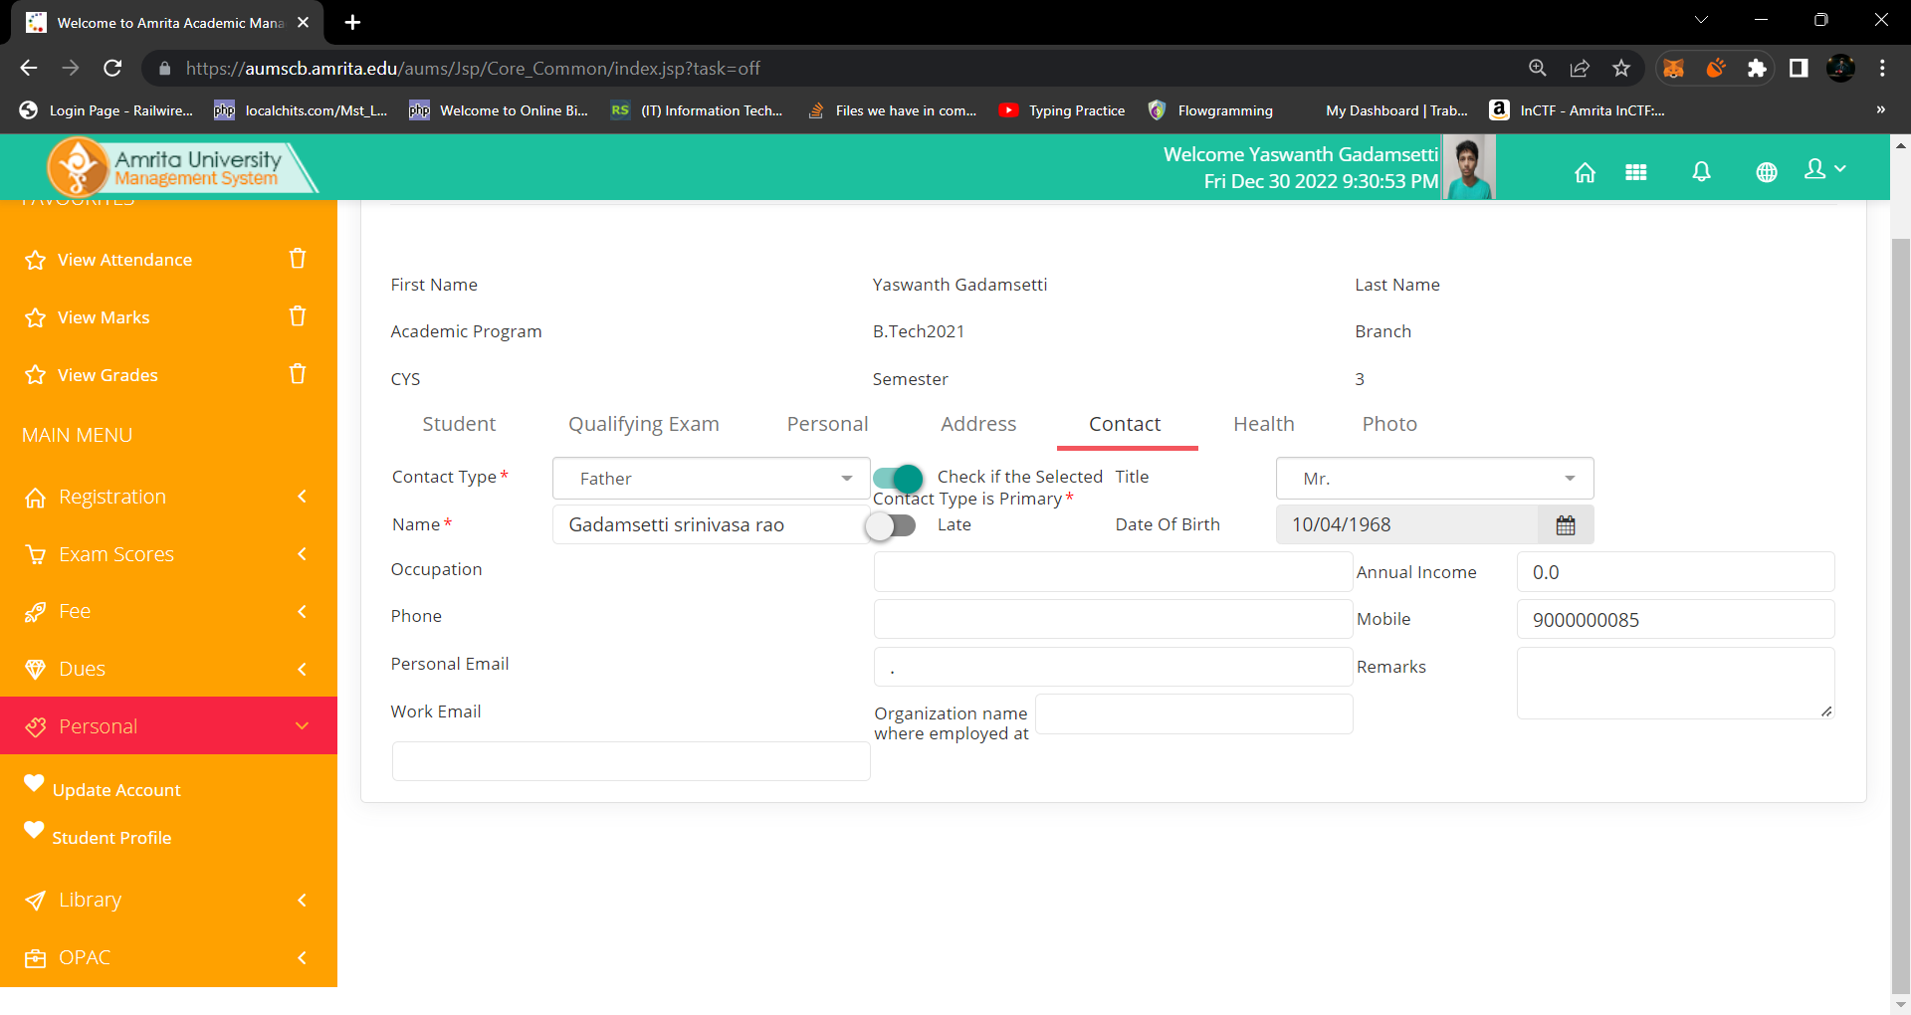

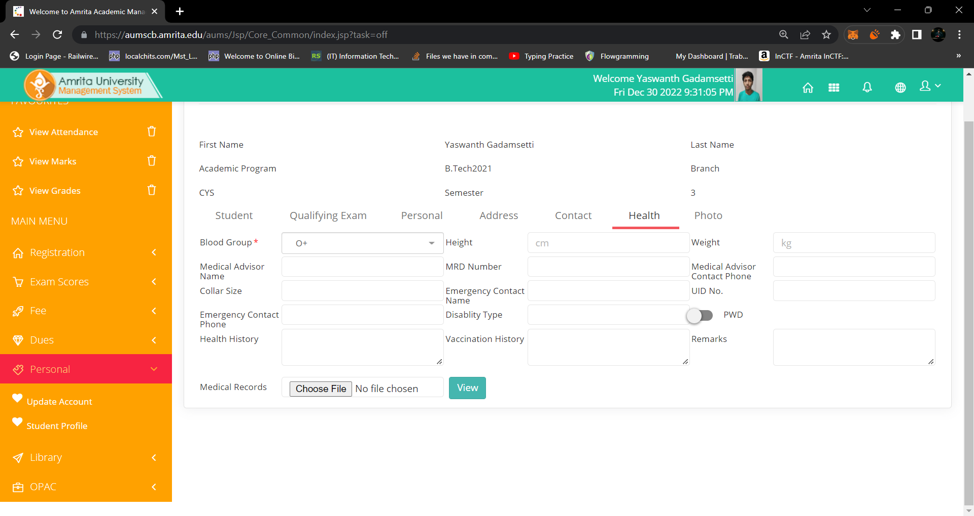

The field alignments should be changed for a better understanding from the users’ perspective.